Operating System

LAB 1

Introduction:

OBJECTIVES:
- Operating System Introduction
- Cores
- 32 bit and 64 bit operating systems
- Windows operating systems
- Task manager
- Operating systems services
Operating systems installed in computer:
Windows 11
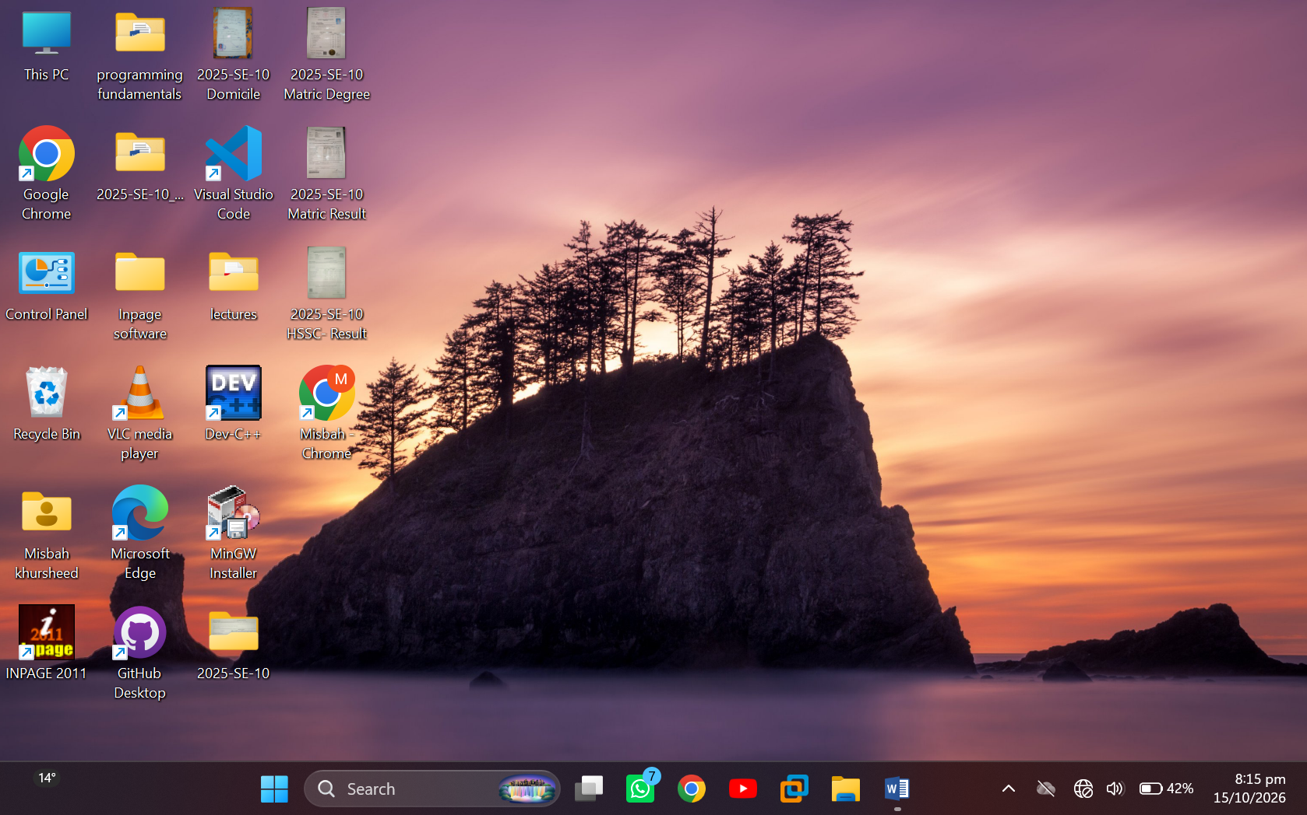

Check the version of Operating System (In windows):
- Click on Computer icon. And select the properties

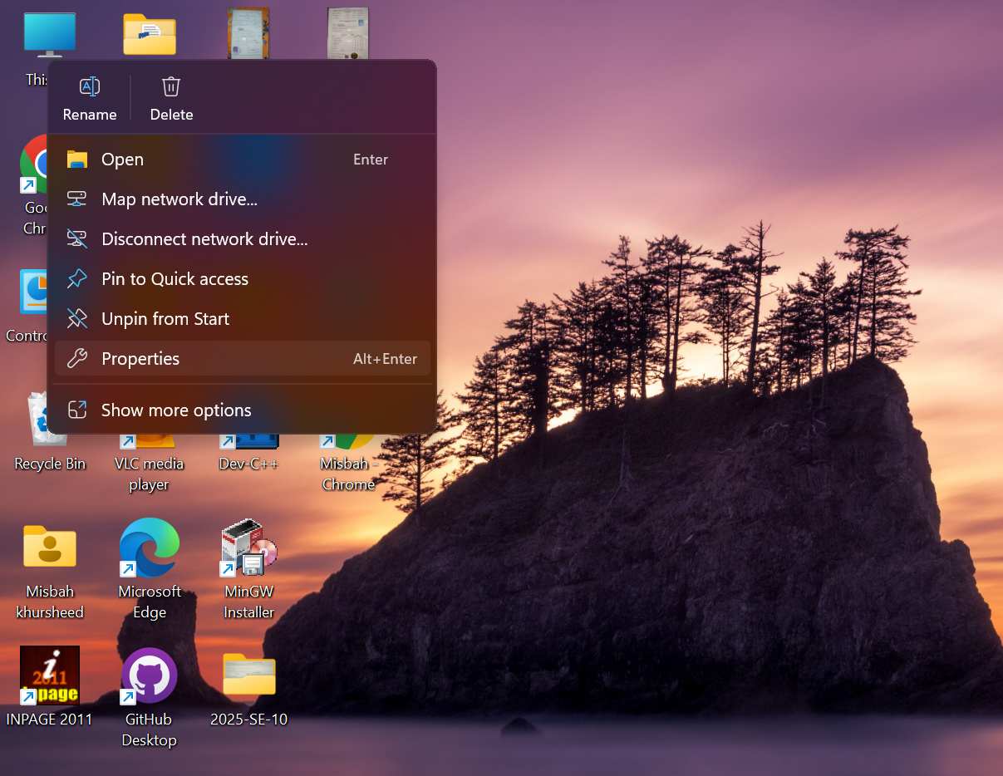

For a 64-bit version operating system, 64-bit Operating System appears for the System type under System. For a 32-bit version operating system, 32-bit Operating System appears for the System type under System.

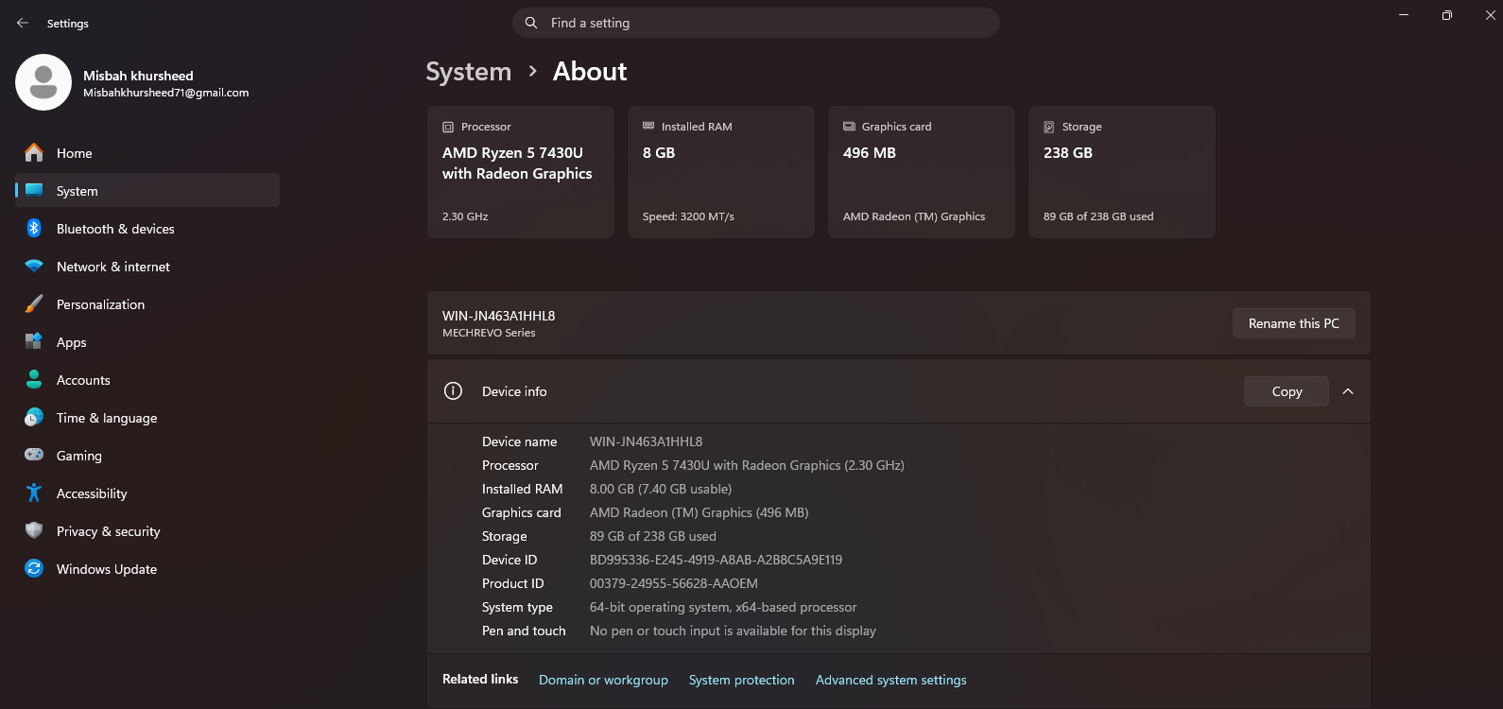

Cores of Processor:
A core, or CPU core, is the "brain" of a CPU. It receives instructions, and performs calculations, or operations, to satisfy those instructions. A CPU can have multiple cores. A processor with two cores is called a dual-core processor; with four cores, a quad-core; six cores, hexa-core; eight cores, octa-core.
A core is a small CPU or processor built into a big CPU or CPU socket. It can independently perform or process all computational tasks. From this perspective, we can consider a core to be a smaller CPU or a smaller processor within a big processor.
The main difference between CPU and Core is that the CPU is an electronic circuit inside the computer that carries out instruction to perform arithmetic, logical, control and input/output operations while the core is an execution unit inside the CPU that receives and executes instruction.
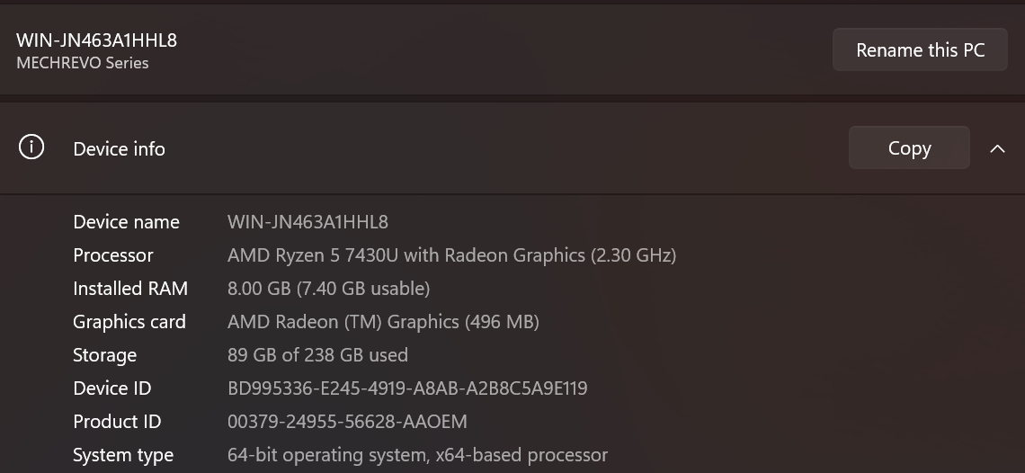

Processor Clock Speed:
A computer's processor clock speed determines how quickly the central processing unit (CPU) can retrieve and interpret instructions. This helps your computer complete more tasks by getting them done faster. Clock speeds are measured in gigahertz (GHz), with a higher number equating to higher clock speed.
The clock speed of my laptop’s processor is shown in red box shown in figure below.
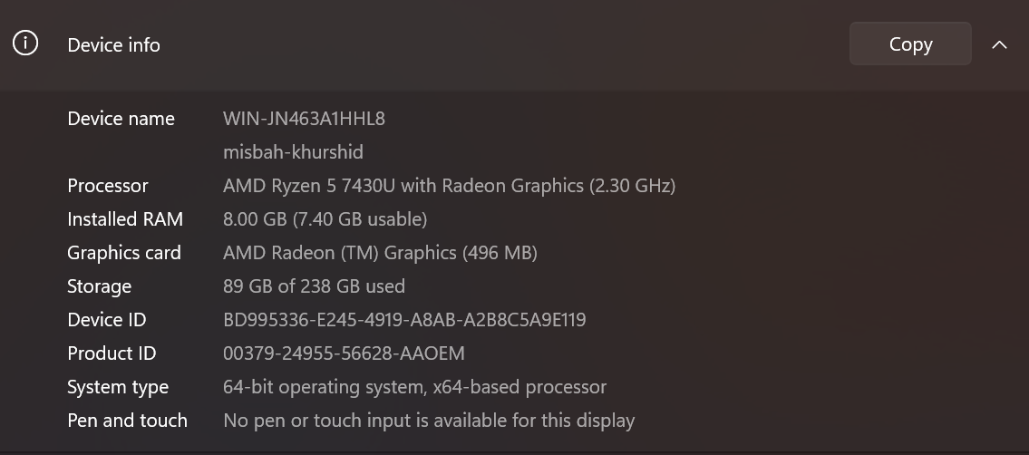

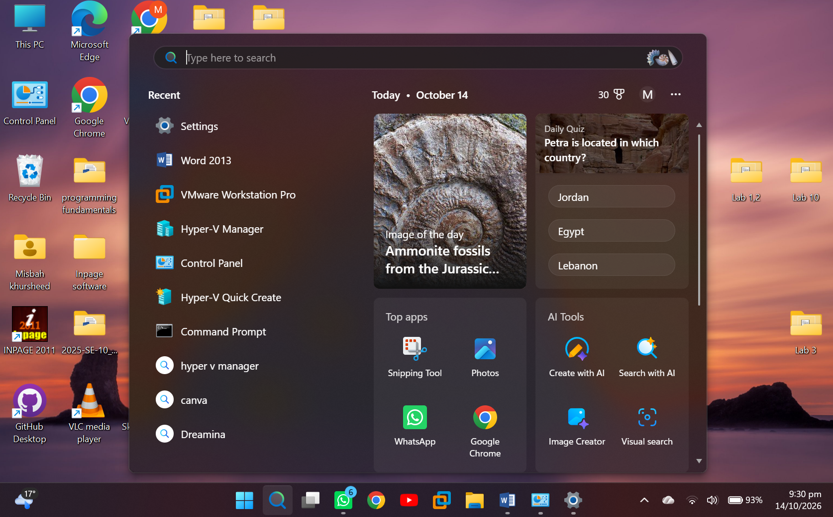
Windows Operating System:

Online Operating Systems:
Windows 98:
To see the interface of Windows 98, go online and write Windows 98 online
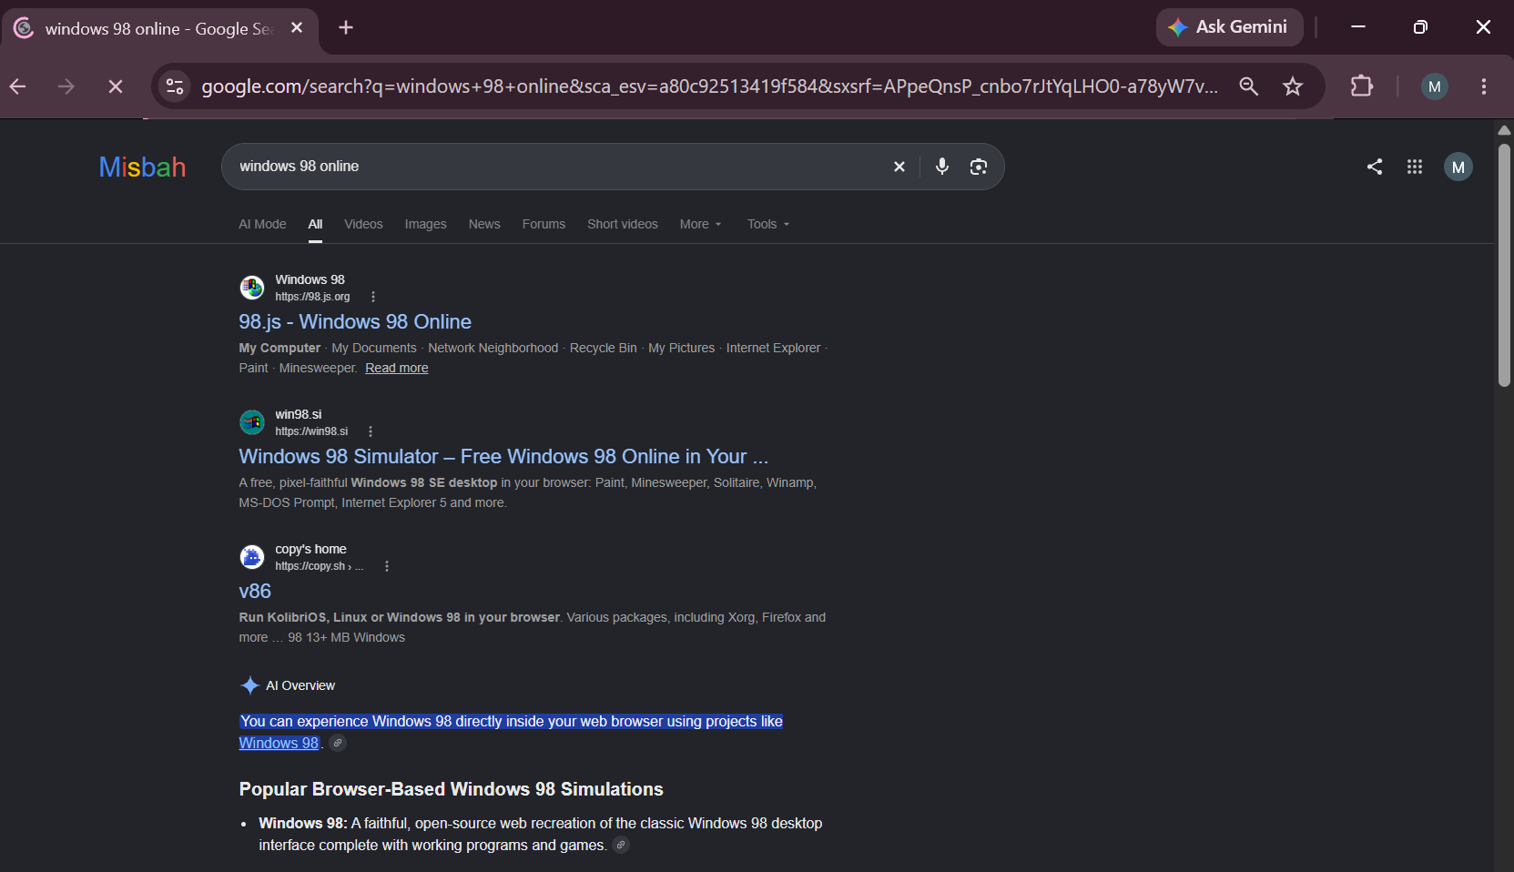

Click on Windows online 98.js
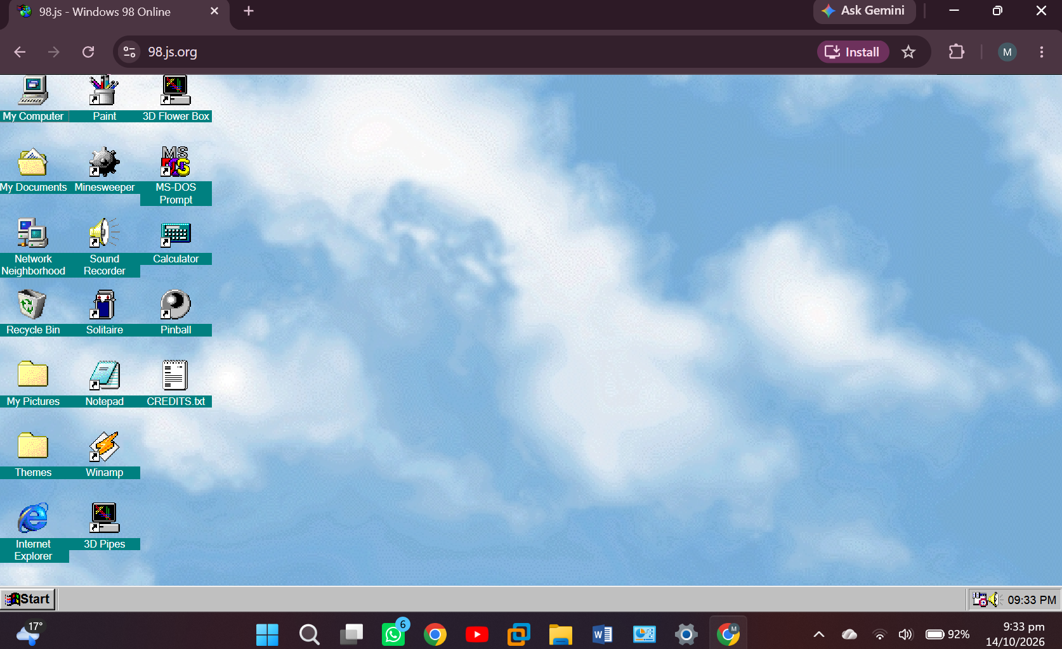

You can click on icons and see how windows 98 was working.
Click on Paint
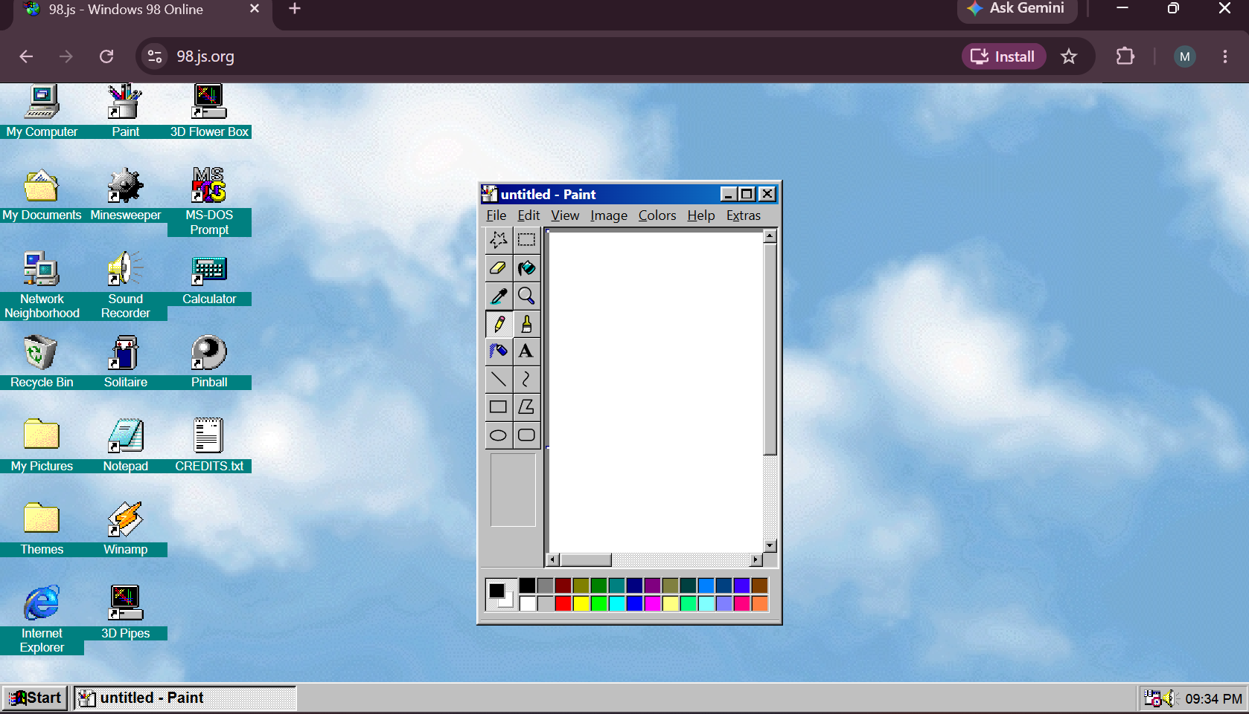

Windows 93:
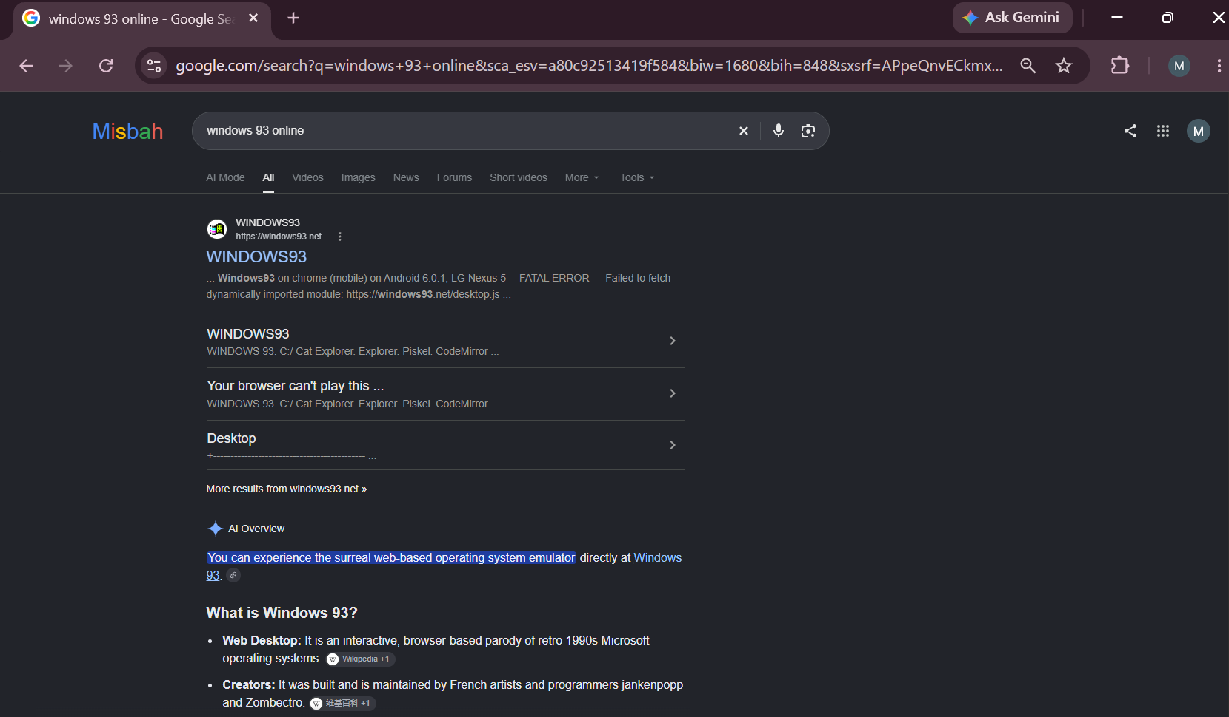
To see the interface of Windows 93, go online and write Windows 93 online.

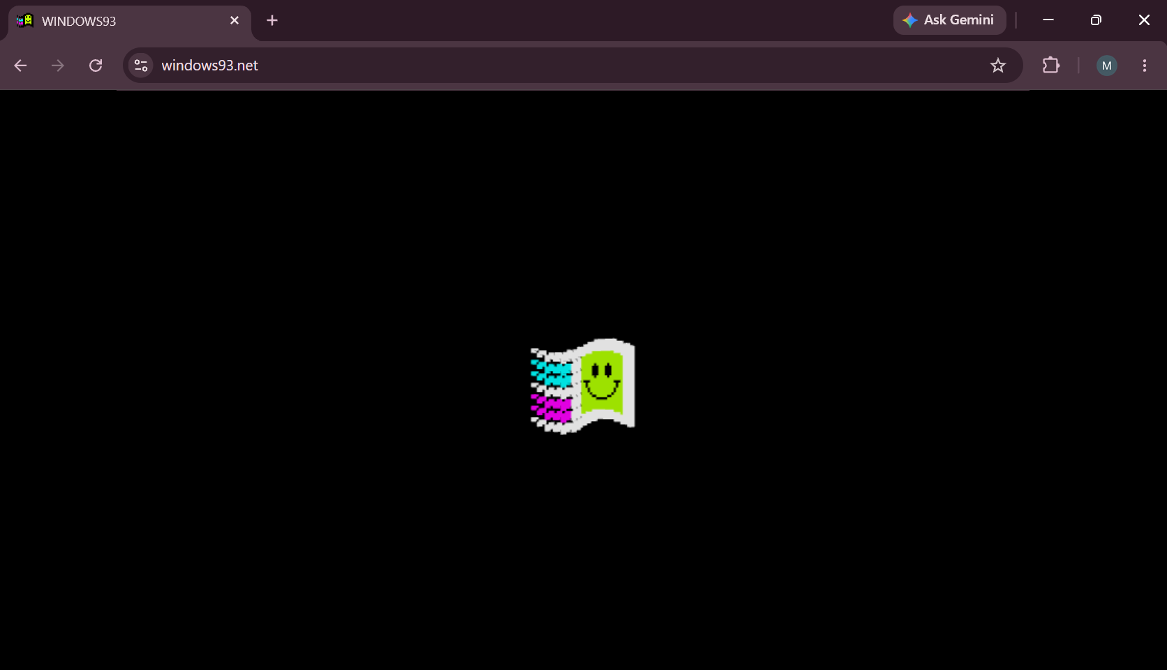
Click on Windows 93

You can click on icons and see how windows 93 was working
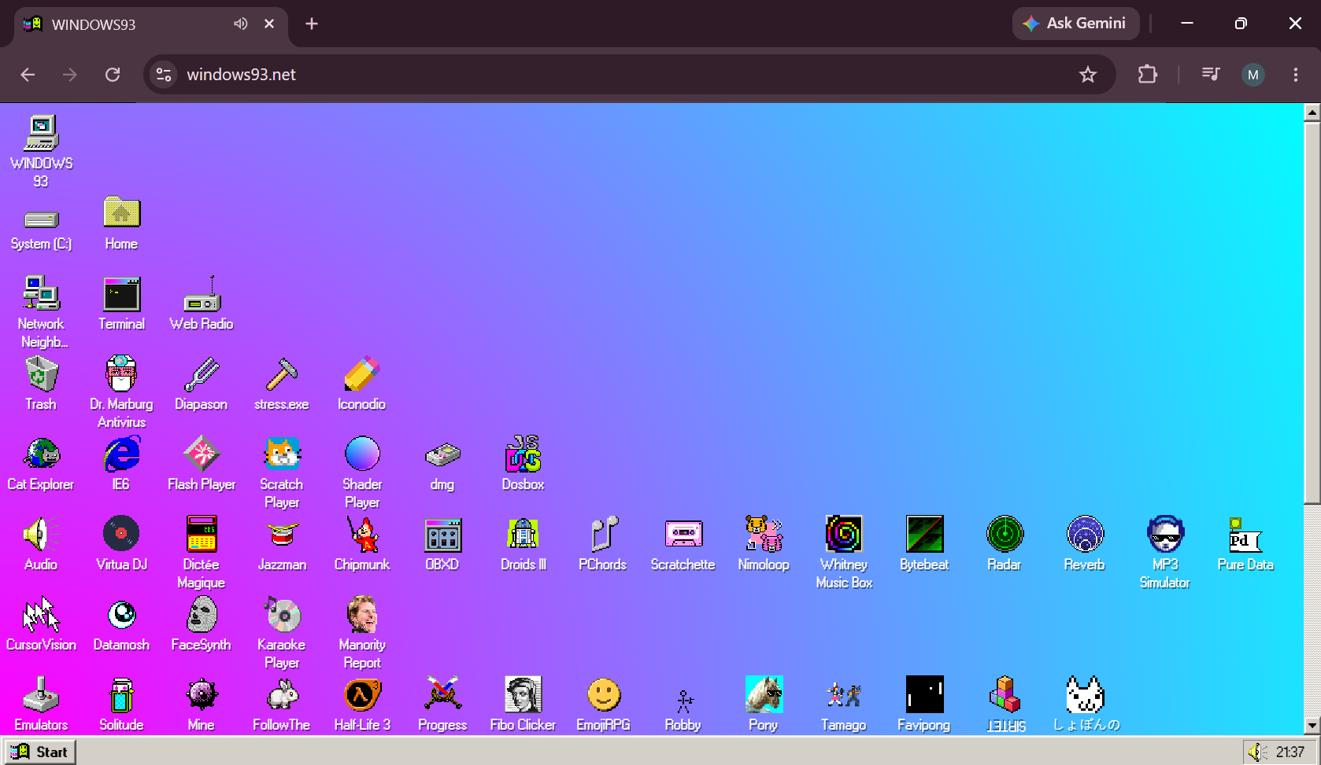

Operating systems services:

To check the services of Operating systems open the ‘run’ then, type “services.msc” and hit
Enter or press OK.

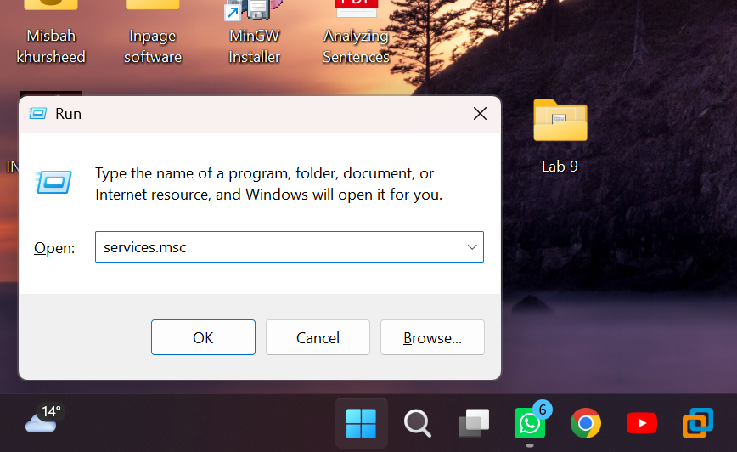

It's the Microsoft Management Console (MMC) file that loads the Services snap-in. It's used to administer Windows services. It provides a GUI to do things like: Start / stop / disable services. It shows you the services that operating systems performed.

Windows Services are applications that typically start when the computer is booted and run quietly in the background until it is shut down.

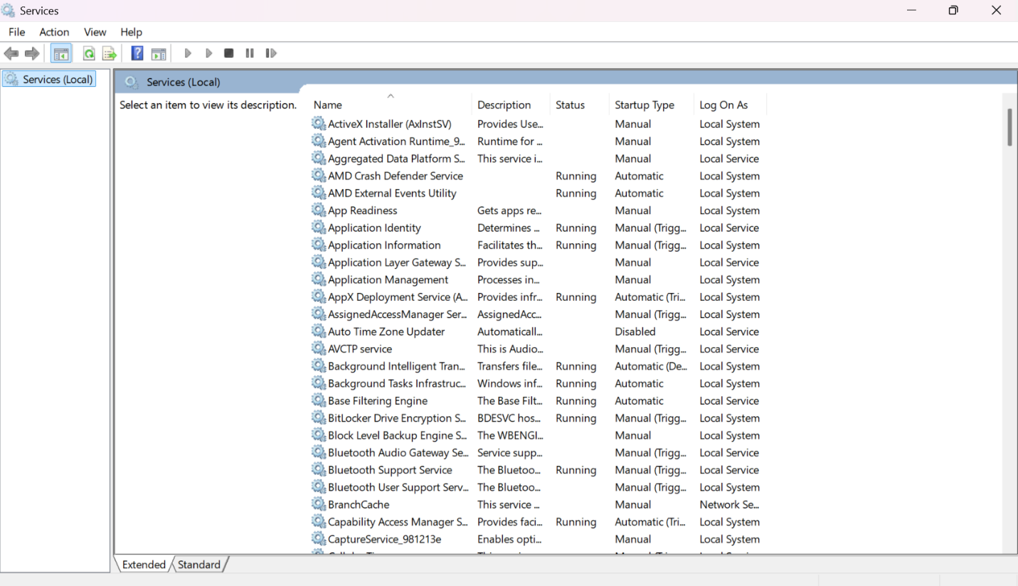

Task Manager:
The Windows Task Manager is a powerful tool packed with useful information, from your system’s overall resource usage to detailed statistics about each process.
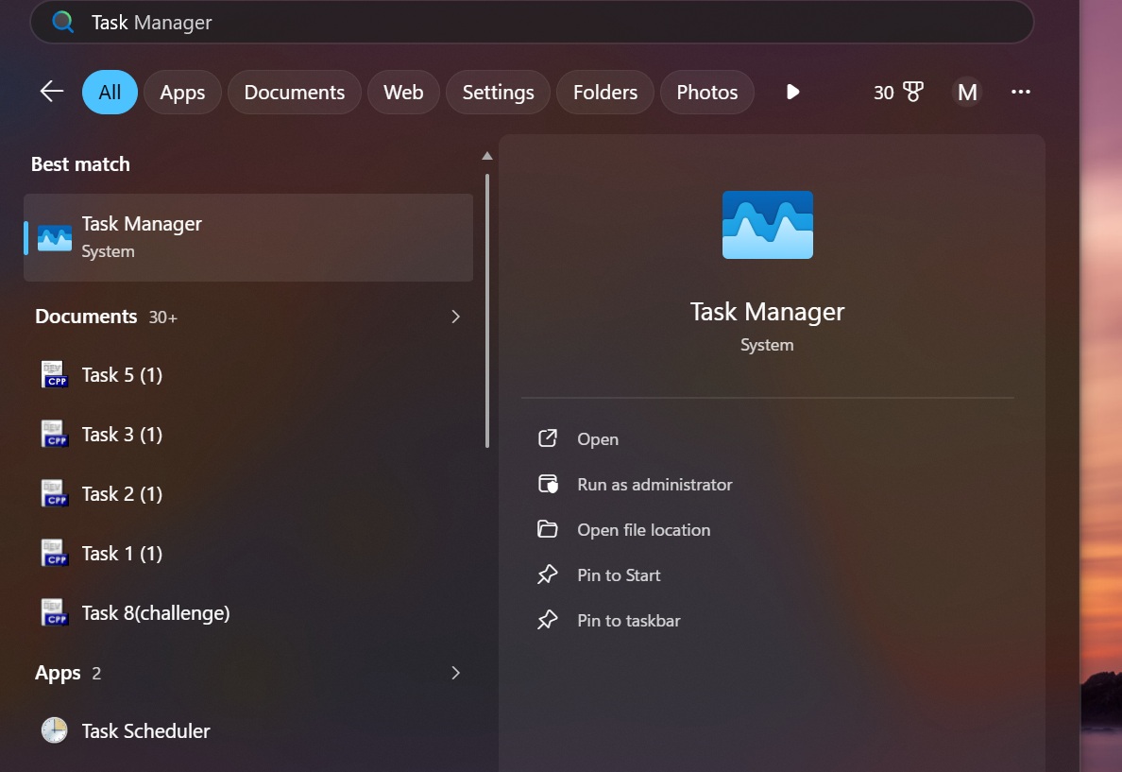

This shows you how much CPU (central processing unit) resources are currently in use on your system, and you can mouse over it to see memory, disk, and network usage

Processes shows a list of running applications and background processes on your system along with CPU, memory, disk, network, GPU, and other resource usage information.

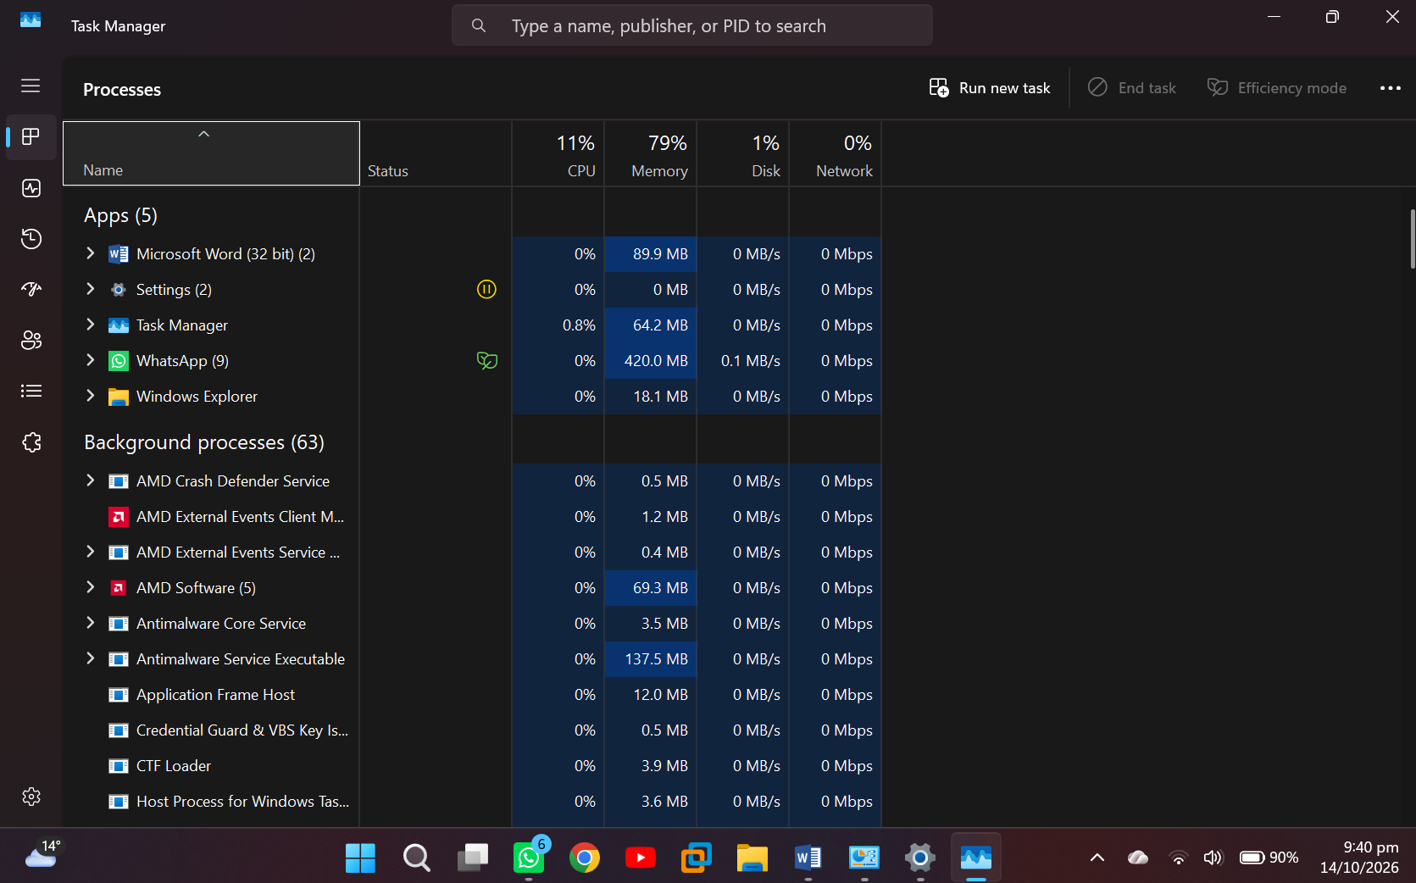

Performance shows Real-time graphs showing total CPU, memory, disk, network, and GPU resource usage for your system. You’ll find many other details here, too, from your computer’s IP to the model names of your computer’s CPU and GPU.

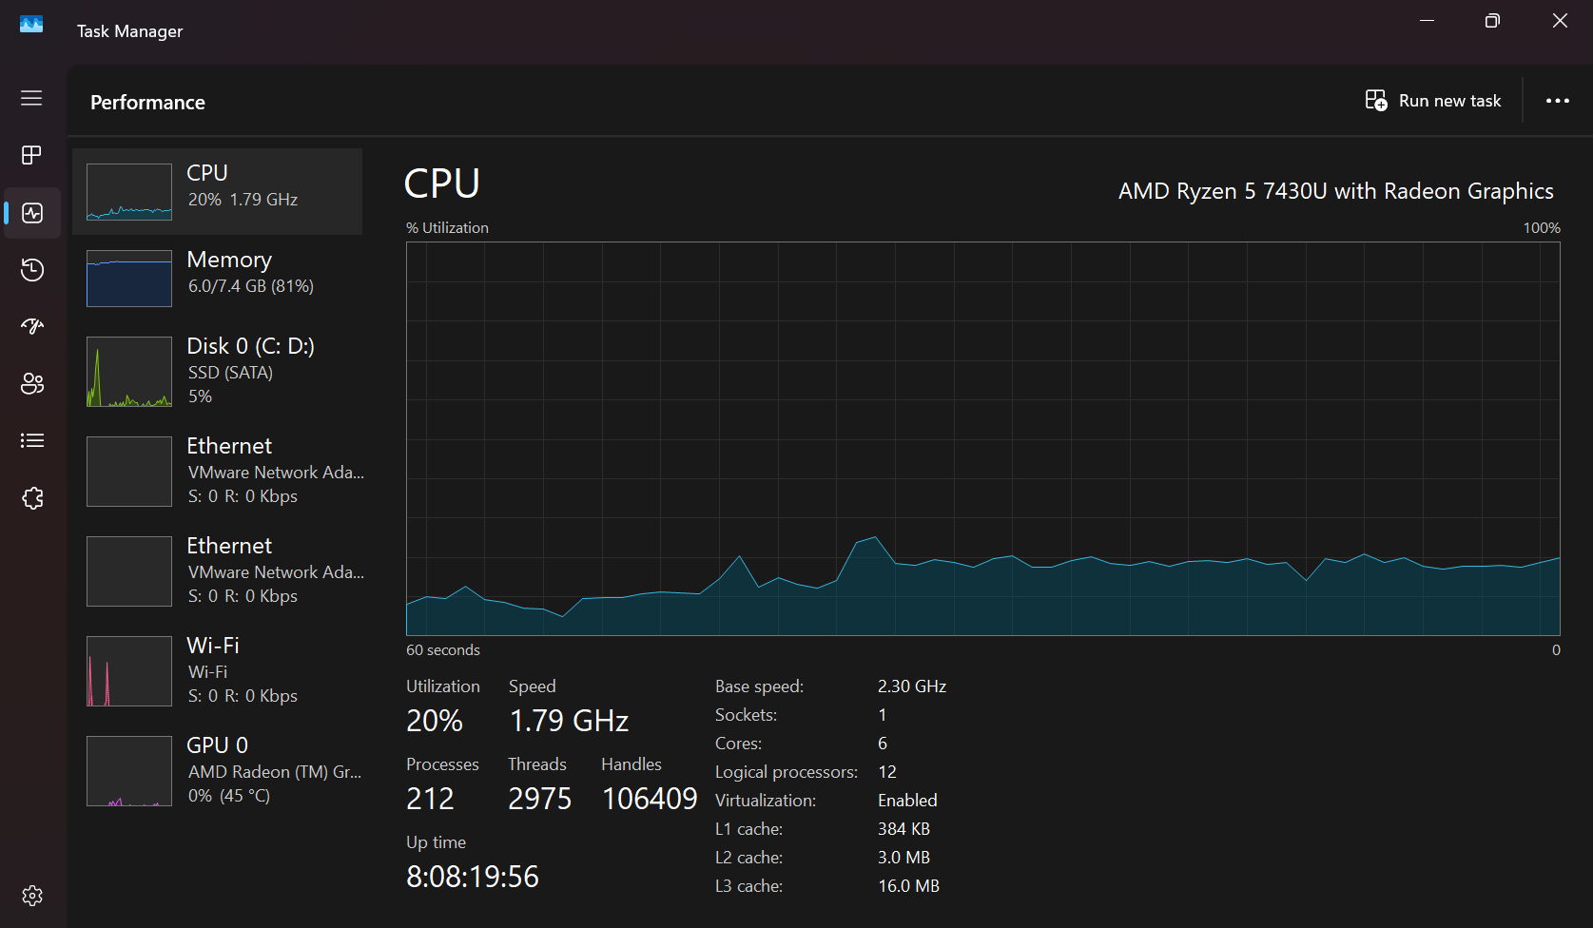

App History shows Information about how much CPU and network resources apps have used for your current user account.

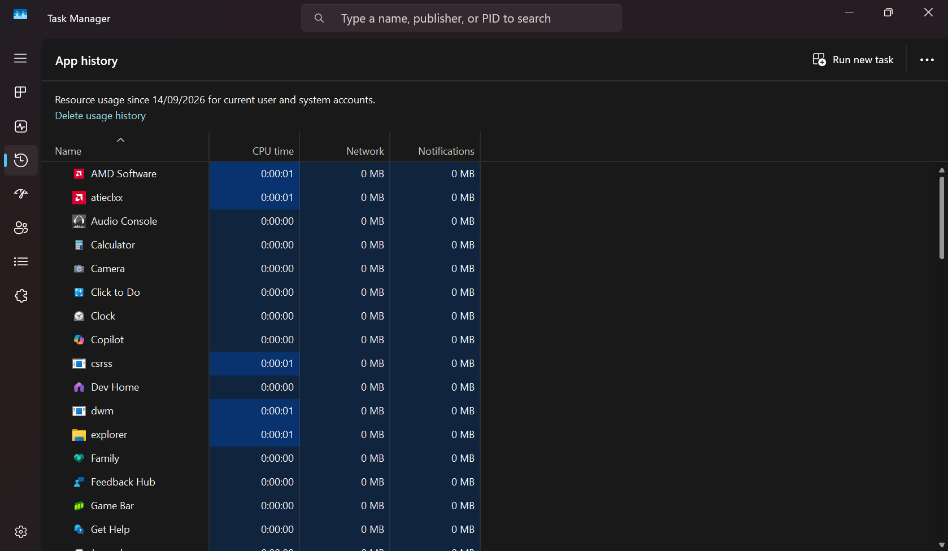

Startup shows a list of your startup programs, which are the applications Windows automatically starts when you sign into your user account. You can disable startup programs from here, although you can also do that from Settings > Apps > Startup.
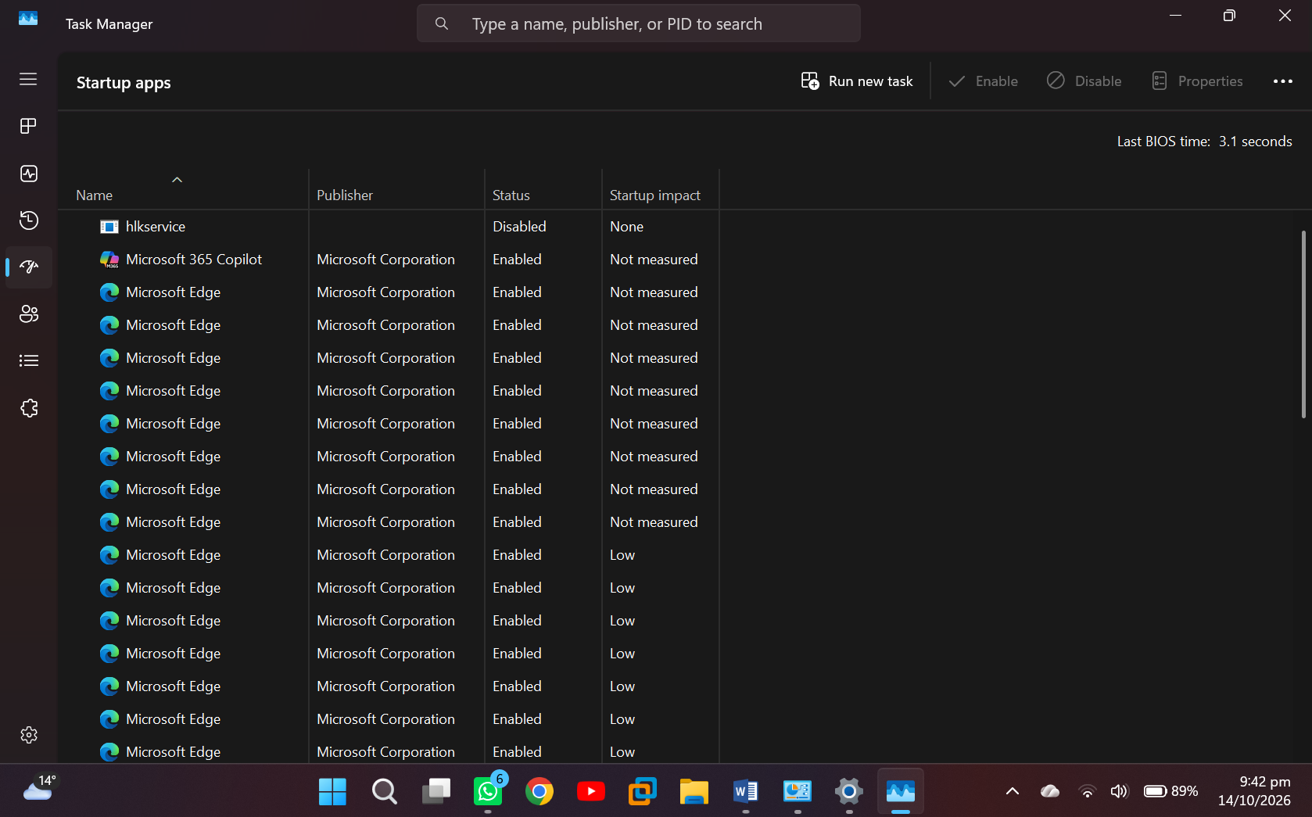

Users shows the user accounts currently signed into your PC, how much resources they’re using, and what applications they’re running.
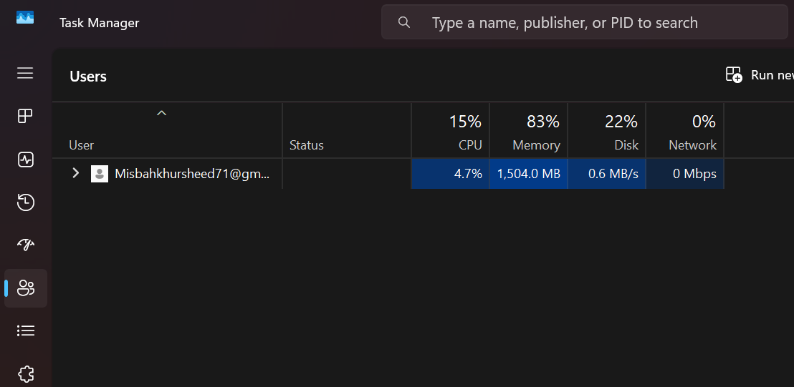

Details shows more detailed information about the processes running on your system. This is basically the traditional “Processes” tab from the Task Manager on Windows 11.
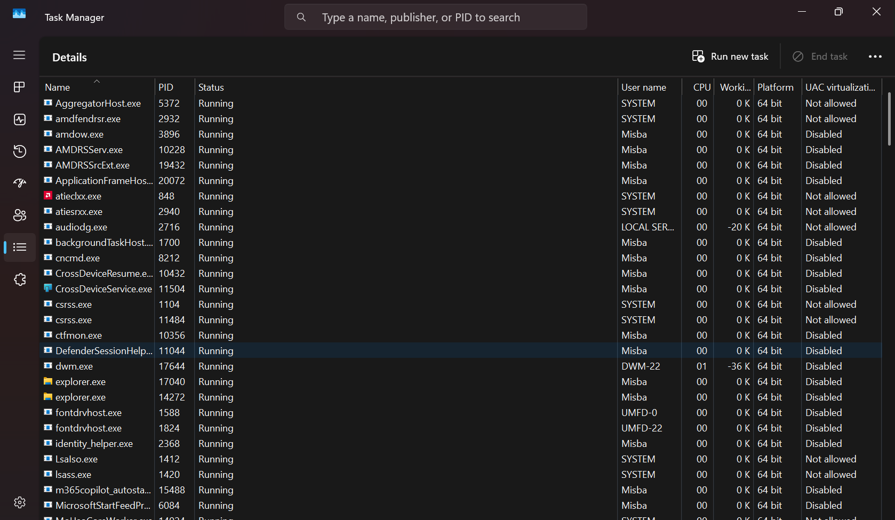
Services shows information about the services running on your system. It provides details about each service including its name, description, status, and group.
